

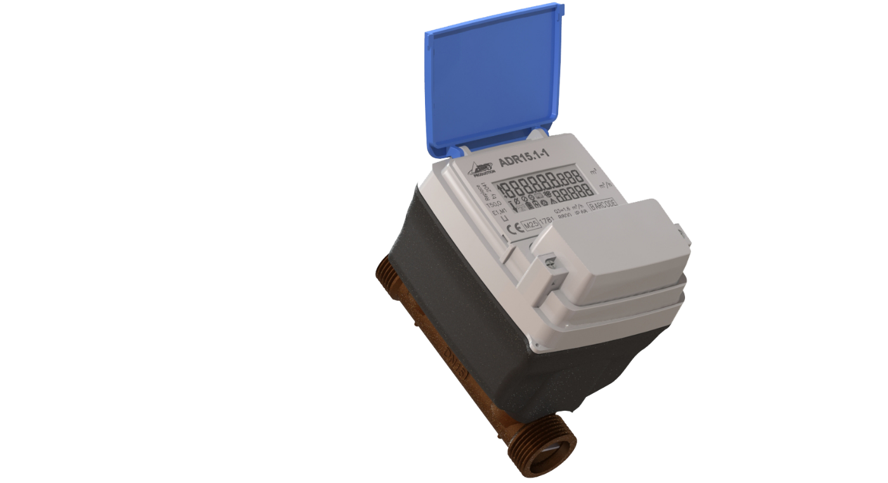

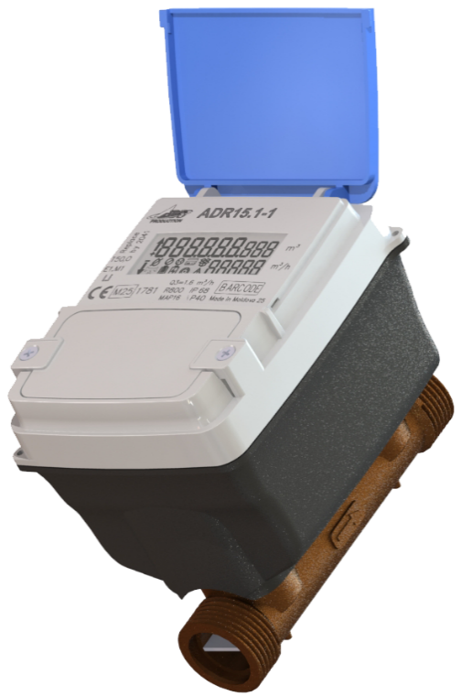

Technical Description

**ADR Series Smart Water Meter**

**Contains**

1. Purpose 4

2. Technical data 4

3. Standards 5

4. Meters designation 6

5. Measurement 7

5.1. Measurement principle 7

5.2. Registers 8

6. Meter States 9

7. Alarms 9

8. Marking 10

9. Design 10

10. Sealing and secure features. 13

11. Sensors 14

12. Meter installation position 14

13. Intelligent power supply 15

13.1. Intelligent power source operation 15

13.2. Power source specifications 15

14. Modes of operation 16

15. Indication 17

16. Communications 19

16.1 Bluetooth Low Energy (optional) 19

16.2 LoRaWAN 19

16.3 WM-Bus 19

16.4. NFC 20

16.5. NB-IoT 20

17. Pressure loss 21

18. Firmware update 21

19. Security features 21

**Revision History**

| **Version** | **Description** | **Date** | |
| --- | --- | --- | --- |
| 1.0 | Original document | | 30.05.2025 |

# Purpose

ADDRA smart water meter of ADR series (hereinafter WM) is based on ultrasonic principle and intended for cold water consumption metering.

The water meter is compliant with OIML R49 class O and is intended for 24-hours indoor or outdoor operation. It withstands ambient air temperature from – 25°C to + 70°C and water temperature from 0.1°C to +50°C.

When installing the WM, note that the meter must be protected against the damage risks due to extreme water or ambient air temperatures.

# Technical data

Main technical characteristics are summarized in the table 1 below:

*Table 1. WM technical characteristics*

|  |  |  |  |  |  |  |
| --- | --- | --- | --- | --- | --- | --- |
| **Characteristic** | **Value** | | | | | |
| **Model** | ADR15 | | ADR20 | | ADR25 | |
| **Nominal diameter** | DN15 | | DN20 | | DN25 | |
| **Thread** | G3/4” | | G1” | | G1¼” | |
| **Connection type** | BSP | | | | | |
| **Permanent flow rate, Q3 (m3/h)** | 1.6 | 2.5 | 2.5 | 4 | 4 | 6.3 |
| **Dynamic range Q3/Q1** | R250  R400  R800 | R250  R400  R800  R1600 | R250  R400  R800 | R250  R400  R800  R1600 | R250  R400  R800 | R250  R400  R800  R1600 |
| **Installation sensitivity class** | U0/D0 | | | | | |
| **Sensitivity threshold (l/h)** | 1 | | | | | |
| **Temperature class** | T50 (0.1 – 50 oC) | | | | | |
| **Storage/transportation temperature** | From -25 to 70 oC | | | | | |
| **Metrological class** | Class 2 | | | | | |
| **Maximum operation pressure** | 1.6 MPa | | | | | |
| **Pressure loss** | Δp40 | | | | | |
| **Protection class** | IP68 | | | | | |
| **Environmental class** | E1, M1, O | | | | | |
| **Installation** | Horizontally/vertically/at angle | | | | | |
| **Power supply** | Internal power supply:   * С type batteries (one or optionally two) * Backup battery 1\2 АА * SPC (Super Pulse Capacitor)   External power supply:   * Two type AA batteries installed in the battery compartment | | | | | |
| **Interfaces** | BLE, NFC for local access | | | | | |

|  |  |
| --- | --- |
| **Characteristic** | **Value** |
| **WAN Communication** | MultiRAT (LoRaWAN, Wireless M-Bus, NB-IoT)  Different frequency ranges:  EU863-870, US902-928, AU915-928, AS923 |
| **Non-volatile memory** | Data storage not less than 10 years |
| **Approvals** | WRAS |

# Standards

*Table 2. Relevant standards*

|  |  |
| --- | --- |
| EN 14154-1:2005+A2:2011 | Water meters - Part 1: General requirements |
| EN 14154-2:2005+A2:2011 | Water meters - Part 2: Installation and conditions of use |
| EN 14154-3:2005+A2:2011 | Water meters - Part 3: Test methods and equipment |
| EN 14154-4:2014 | Water meters - P art 4: Additional functionalities |
| ISO 4064-1:2017 (OIML R 49) | Water meters for cold potable water and hot water -  Part 1: Metrological and technical requirements |
| ISO 4064-2:2017 (OIML R 49) | Water meters for cold potable water and hot water -  Part 2: Test methods |
| ISO 4064-3:2017 (OIML R 49) | Water meters for cold potable water and hot water -  Part 3: Test report format |
| ISO 4064-4:2017 (OIML R 49) | Water meters for cold potable water and hot water -  Part 4: Non-metrological requirements not covered in ISO 4064-1 |
| ISO 4064-5:2017 (OIML R 49) | Water meters for cold potable water and hot water -  Part 5: Installation requirements |
| MID Directive 2014/32/EC | Measuring Instruments Directive of the European Parliament and of the Council of 26 February 2014 on the harmonization of the laws of the Member States relating to the making available on the market of measuring instruments |
| LoRaWAN®  L2 1.0.4 Specification | The LoRaWAN® 276 network protocol optimized for battery277 powered end-devices. |
| LoRaWAN®  Regional Parameters RP002-1.0.4 | LoRaWAN Regional Parameters for different regulatory regions worldwide |
| IEEE 802.15.4-2006 | IEEE Standard for Information technology-- Local and metropolitan area networks-- Specific requirements-- Part 15.4: Wireless Medium Access Control (MAC) and Physical Layer (PHY) Specifications for Low Rate Wireless Personal Area Networks (WPANs) |
| NIST-AES | Advanced Encryption Standard (AES). National Institute of Standards and Technology 2001, updated 2023 |
| EN 13757-3:2013-08 | Communication systems for and remote reading of meters – Part 3: Dedicated application layer |
| EN 13757-4:2019 | Communication systems for meters - Part 4: Wireless M-Bus communication |
| EN 13757-7:2018 | Communication systems for meters - Part 7: Transport and security services |
| IEC 62056 | Electricity metering data exchange – DLMS/COSEM suite |

# Meters designation

WM meter family defines the family of potable water meters with different functionality developed by ADD GRUP. The following system is used to indicate the types of meters within the family:

**ADR X - X1 - X2**

**Series name**

**Model**

**Design Index**

**Communication Protocol Index**

ADR water meter family

X=15 means D15; X=20 means D20;

X=25 means D25

X1 - natural number (see below)

X2 - natural number (see below)

Thus, the designation ADR is used to identify a series of meters with DN15, DN20 and DN25. Identifier “Design index” determines the meter body length *LB* as follows:

|  |  |  |  |
| --- | --- | --- | --- |
| **X1** | **DN15** | **DN20** | **DN25** |
| 1 | *min_LB* =110mm | *min_LB* =130mm | *min_LB* =190mm |
| 2 | *max_LB* =165mm | *max_LB* =195mm | *max_LB* =225mm |
| numbers from 10 to 20 | reserved for possible *LB* between *min_LB* and *max_LB* | reserved for possible *LB* between *min_LB* and *max_LB* | reserved for possible *LB* between *min_LB* and *max_LB* |

Identifier “Communication protocol” is the natural number identified meter RF communication protocol. Communication protocol is defined by legally non-relevant part of the meter firmware. In ADR serial meters the following communication technologies can be supported:

* LoRa;
* NB-IoT;
* Wireless M-bus;
* BLE;
* NFC.

Several assembling variants are implemented:

* WM with LoRa communication module
* WM with NB-IoT communication module
* WM with NB-IoT/LoRa communication module. Simultaneous operation of LoRa and NB-IoT is not allowed. These modules work independently according to the set scenario.

# Measurement

## 5.1. Measurement principle

The meter features a flow sensor based on proven ultrasonic measurement. The flow sensor is used to measure the average flow rate and estimate the difference of measured transit time between the sound signals along with and against the direction of the flow.

The flow meter is equipped with 2 ultrasonic transducers used to send sound signals with/against the flow (see Figure 1).

The meter calculates the consumed water volume based on signals from flow sensor. Measured and calculated data are stored in the meter non-volatile memory and can be presented on the meter display.

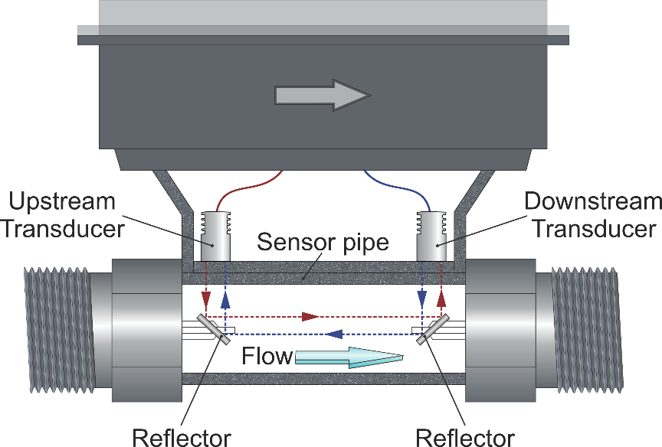

*Fig.1. Measurement principle*

The meter calculates water flow currently according to a fixed measuring cycle. The measurement data is captured each hour, for other measuring cycles (day, month, year) the volume is calculated. All data are saved in non-volatile memory.

The WM has no moving parts and requires no maintenance. The WM is resistant to air passage. The meter measures potable water parameters with particulates and air impurities within the accuracy class, according to the standard for the potable water and installation rules.

## 5.2. Registers

Each meter is identified by its serial number. The following values are registered:

*Table 3. WM values*

|  |  |
| --- | --- |
| **Values** | **Description** |
| Volume | Current reading of accumulated water volume  Format in normal mode (to be agreed with a customer) ######.### m3  Format in test mode: ###.###### m3 |
| Reverse volume | Current reading of accumulated water volume in reverse direction  Format in normal mode (to be agreed with a customer) ######.### m3  Format in test mode: ###.###### m3 |
| Clock | Actual date and time |
| Flow rate | Current velocity of water flow in both directions |
| Water temperature | Actual value of water temperature |
| Ambient temperature | Actual value of ambient temperature |

The WM stores the historical data in three profiles. The parameter sets differ for different archives and can be negotiated as well as storage capacity.

Data storage capacity depends on the set of parameters stored in one archive record. See an example below:

Parameters set:

* Time
* AMR status
* Accumulation volume in the forward and reverse directions

Alarm

Media temperature

Storage capacity:

|  |  |
| --- | --- |
| **Monthly** | 480 months |
| **Daily** | 480 days |
| **Hourly** | 250 days |

The water meter registers and records alarms as:

* info codes which represents water meter flags of certain alarm situations;
* alarm events in the relevant event log depending on the event type, along with the time stamp;
* special symbols on the meter display.

Each of 5 Event logs store up to 120 events.

All metrological data and parameters are secured due to hardware and software protection:

* Metrology MCU programming (JTAG) is disabled and meter is sealed;
* Legally non-relevant software has no any interface to change these parameters.

# Meter States

Water meter can be in one of the states described in Table 4.

*Table 4. WM states*

|  |  |
| --- | --- |
| **State** | **Description** |
| **Off** | No battery operating voltage |
| **Active** | Powered.  The water meter measures and displays the current parameter on the LCD.  Can exchange data via BLE and WAN modem. |

# Alarms

Water meter records alarm situations as follows in Table 5.

*Table 5. WM alarms*

|  |  |
| --- | --- |
| **Alarm** | **Description** |
| **DRY** | The water meter is not filled with water.  In this case, there is no measurement of consumption. |
| **REVERSE** | Water flows in wrong direction.  Reverse water flow more than Q1 detected |
| **LEAK** | Water flows continuously for more than configurable period (e.g. 24 hours). |
| **BURST** | The water flow is constantly high for more than configurable period  (e.g. 30 minutes). |
| **TAMPER** | Indicates that the water meter has been opened. |
| **LOWBAT** | Indicates low battery. Readout messages with the battery percentage data can be sent both locally and remotely. |

In case an alarm is registered the WM can send alarm notification to the Control Center. The list of alarms to be sent is configurable.

# Marking

Marking is set on the WM case according to ISO 4064-1.

Symbols and text are engraved on the nameplate by a laser to be in contrast with the background are easily visible to the user.

Since there is not enough space for the markings on the meter case, the symbol is placed on the meter nameplate, accompanying by appropriate information in the technical documentation. Relevant parameters and information are marked with this symbol in Technical description and Installation manual to proper use of the meter.

See as an example summary information in the table below.

Throughout the whole document this additional information is also marked with

|  |  |
| --- | --- |
| Storage temperature  (IEC 60721-3-1) | -40 °C to +70 °C |
| Accuracy class | 2 |
| Q3/Q1 | 1600 |
| IP rating (IEC/EN 60529) | IP68 |
| Pressure loss | Δp 63 |
| Meter base standards | OIML R49 |
| sensitivity class | U0/D0 |
| Environmental classification | E1, M1, O |

# Design

The water meter is an one-piece device with measurement transducer, calculator, and indicating LED as integral parts.

The meter is made from durable components:

* Ultrasonic measuring pipe – Brass with 40% fiberglass GF (depending on the meter model).
* Housing – Polycarbonate (PC).

The meter is equipped with intelligent power source comprising internal and external parts, which ensures the meter operation and communication. See details in section 13.

Overall dimensions of the meter are presented in Figure 2:

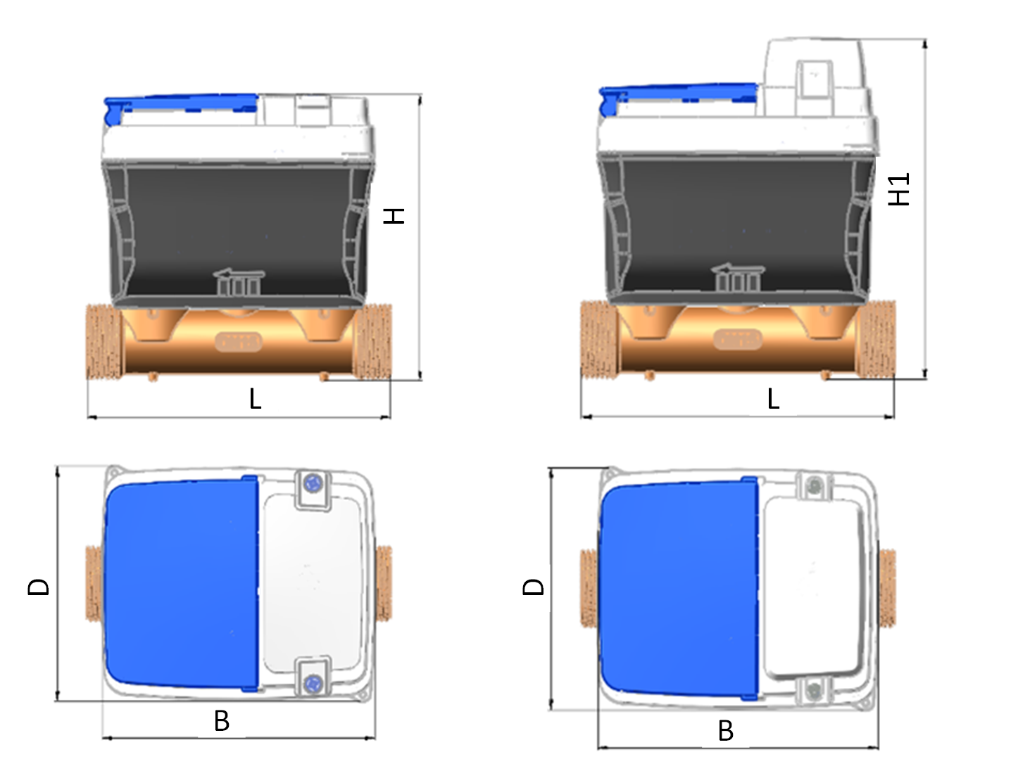

*Fig.2. WM overall dimensions.*

*Table 6. WM dimensions for different pipe diameters*

|  |  |  |  |
| --- | --- | --- | --- |
| **Pipe**  **diameter** | **Dimensions** | **WM with long brass pipe** | **WM with short brass pipe** |
| **D15** | **L** | 165 | 110 |
| **H/H1** | 103/119 | 103/119 |
| **D** | 85 | 85 |
| **B** | 99 | 99 |
| **D20** | **L** | 195 | 130 |
| **H/H1** | 109/125 | 109/125 |
| **D** | 85 | 85 |
| **B** | 99 | 99 |
| **D25** | **L** | 225 | 190 |
| **H/H1** | 116/132 | 116/132 |
| **D** | 85 | 85 |
| **B** | 99 | 99 |

The meter basic parameters are placed on the face surface as illustrated below:

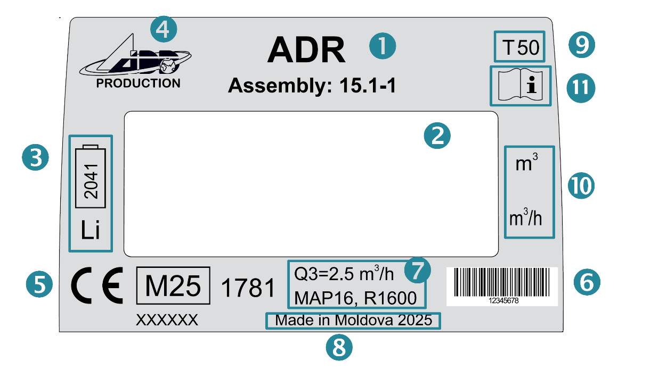

*Fig.3. WM nameplate elements- to be modified*

*Table 7. WM nameplate elements description*

|  |  |
| --- | --- |
| ➊ | Meter model |
| ➋ | Display to view consumption data and states |
| ➌ | Battery expiry date |
| ➍ | Meter manufacturer |
| ➎ | CE mark accompanied with the [last](https://context.reverso.net/%D0%BF%D0%B5%D1%80%D0%B5%D0%B2%D0%BE%D0%B4/%D0%B0%D0%BD%D0%B3%D0%BB%D0%B8%D0%B9%D1%81%D0%BA%D0%B8%D0%B9-%D1%80%D1%83%D1%81%D1%81%D0%BA%D0%B8%D0%B9/last) two [digits of the year](https://context.reverso.net/%D0%BF%D0%B5%D1%80%D0%B5%D0%B2%D0%BE%D0%B4/%D0%B0%D0%BD%D0%B3%D0%BB%D0%B8%D0%B9%D1%81%D0%BA%D0%B8%D0%B9-%D1%80%D1%83%D1%81%D1%81%D0%BA%D0%B8%D0%B9/digits+of+the+year) of manufacture (YY after M sign) and identification number of the notified body XXXX |
| ➏ | Barcode with serial number |
| ➐ | Technical parameters |
| ➑ | Place of manufacturing and the [last](https://context.reverso.net/%D0%BF%D0%B5%D1%80%D0%B5%D0%B2%D0%BE%D0%B4/%D0%B0%D0%BD%D0%B3%D0%BB%D0%B8%D0%B9%D1%81%D0%BA%D0%B8%D0%B9-%D1%80%D1%83%D1%81%D1%81%D0%BA%D0%B8%D0%B9/last) two [digits of the year](https://context.reverso.net/%D0%BF%D0%B5%D1%80%D0%B5%D0%B2%D0%BE%D0%B4/%D0%B0%D0%BD%D0%B3%D0%BB%D0%B8%D0%B9%D1%81%D0%BA%D0%B8%D0%B9-%D1%80%D1%83%D1%81%D1%81%D0%BA%D0%B8%D0%B9/digits+of+the+year) |
| ➒ | Temperature class |
| ➓ | Measurement units |
|  | Special IEC 60417 symbol used on metering equipment (according to  ISO 7000). Identifies that the operating instructions should be considered when operating the device. |

# Sealing and secure features.

The meter body is closed by a non-separable cover to ensure the meter complete protection.

The meter cannot be accessed without visible damage of the enclosure such as breakage and cracks.

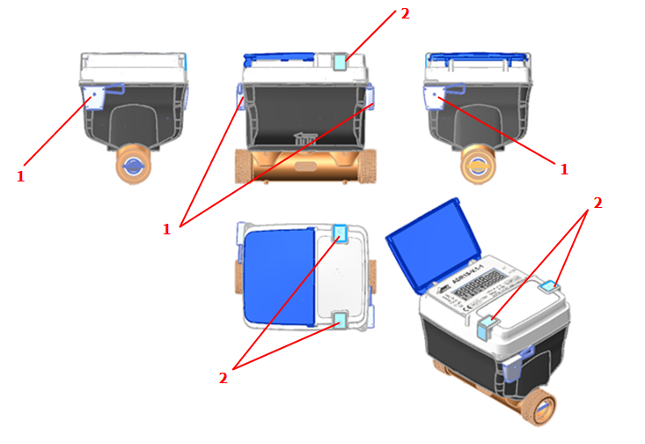

*Fig.4. WM general view and sealing options (The meter without the external power source is taken as an example).*

There are several sealing options that allows the meter additional protection according to the local regulations:

* Two optional security seals (pos. 1 in Fig.4). The meter design provides holes to thread the security seal wires.
* Two optional security self-destructive stickers (pos. 2 in Fig.4) to protect power source.

In Fig.4 see as an example of sealing positions: 3 with no seal and 1 with already installed security seal.

# Sensors

The meter is equipped with several sensors:

|  |  |  |
| --- | --- | --- |
| **Measurement sensors** | | |
| Water temperature sensor  (optional) | Intended to measure water temperatures in pipelines   * PT1000 resistance thermometer compliant with IEC 60751 * Class «B» * Operating temperature range： from -25 up to +70℃ * Two-wire connection | |
| Pressure sensor  (optional) | To measure water pressure in pipelines   * pressure from 0 to 1.6MPa * output I2C * Operating temperature range: from -25 up to +70C * VCC 3.3V * accuracy 1% | |
| **Anti-tampering means** | | |
| Case opening sensor | * Push button switch type * Operates from any power source | |
| Magnetic field detection sensor | * Hall-effect sensor | |
| Accelerometer unit | Intended to control ADR position in space  Operates from any power source | |

Simultaneous operation of pressure sensor and water temperature sensor are not possible.

In case of tamper attempt, the relevant alarm is registered in the Event log and is indicated on the meter display. Information on alarms can be transmitted via WAN channel to a Control Center or can be obtained locally via BLE.

# Meter installation position

During the meter installation, pay attention to the flow direction, which is indicated by an arrow on the meter side (see Fig. 2).

The meter can be mounted on a pipe horizontally, vertically, or at any angle (including the display down position), unless the flow direction arrow is downward.

It is recommended to mount the meter in such a way that the display can be read easily.

# Intelligent power supply

## 13.1. Intelligent power source operation

Water meter is equipped with Intelligent Power supply source, that allows optimizing the meter operation and increase its working time.

The meter operates on internal or external power source.

|  |  |
| --- | --- |
| Internal power source | * С type battery pack (С1) to ensure the meter complete functionality. * Backup battery 1/2 АА to ensure measurement mode (see section 12) * SPC (Super Pulse Capacitor), Helper   Both internal batteries and SPC are constructional combined into a single assembly with a common connector.   * Optionally, С type battery (C2) can be connected parallel to C1 |
| External power source | Two parallel connected batteries (type AA) which are installed in the battery compartment |

Both battery packs (internal or external power source) operate along with the internal SPC which provides all the necessary power supply for the meter operation and ensures protection against voltage fluctuations and high frequency noise. The batteries are intended for the SPC charging only.

The battery is considered as discharged when the voltage is less than 2.9 V.

Battery switching is implemented as follows:

* In presence of serviceable external battery (2xAA), the meter is powered from an external source. Along with this, C1 (and C2, if any) is automatically disconnected. Only periodic status checks are allowed.
* When the external battery pack is discharged or removed, two variants are possible:
* if the С1 battery (and C2 if any) is in working condition, the meter automatically switches to power from this battery. The meter remains in normal mode.
* If the C1 battery (and C2 if any) is discharged, the meter switches to the "measurement" mode from 1/2 АА battery.
* When operating in normal mode, the 1/2AA battery does not contribute to powering process of the meter. Only periodic status checks are allowed.

## 13.2. Power source specifications

Power source technical specifications are as follows:

* Input voltage Uinp =3.6 ±0.1V.
* Output voltage Uout =3.3±0.1V with maximum long-term current up to 350 мА,   
  Ipeak=500 мА

Product Life is determined by the battery set and communication conditions.

With the average consumption of 0.02344 mA the life time from one battery C1 will be more than 16 years. An additional internal battery C2 or external battery pack 2xAA can be installed if an increased frequency of data exchange with the meter is expected, or the installation will be in the obviously poor communication conditions.

Backup battery 1/2AA should provide a service life of 16 years, including half a year in the measurement mode. The average current consumption in the measurement mode is 0.0132 mA.

# Modes of operation

The meter operates in the following modes.

|  |  |
| --- | --- |
| **Mode** | **Description** |
| **NORMAL** | Normal mode is the default mode in which the meter operates while in service  In normal mode the meter is supplied by an internal type С battery or external source, and full functionality is supported:   * Complete measurements (including temperature measurement) * Displaying data on LCD * Communication via all available channels, such as BLE, NFC, LoRA, NB-IoT * Opening sensor support |
| **MEASUREMENT** | In the measurements mode the meter is supplied by 1/2AA battery providing the following features.   * Complete measurements (including temperature measurement) * Displaying data on LCD * Communication via NFC * Opening sensor support |
| **TRANSPORTATION** | is usually used to decrease the battery power consumption during the meter transportation (before installing on site). Main features of the transportation mode:   * All communication channels are disconnected. * Transportation Mode is activated in initial configuration during production stage. * Transportation mode is disabled after 10 liters of water has flown (in current version). |
| **TEST** | is designed for the meter verification. When the test mode is activated:   * Measurements occur 8 times per second whether there is water in a pipe or not.   (Note that in normal mode, measurements occur 2 times per second in case there is no water and 8 times per second in the presence of water in the pipe).   * Accumulated water (8.0.1.0.0.255) is displayed on LCD in ###.###### format (3 digits before the decimal point and 6 decimals). Measuring unit is m3. * Test mode is activated by a command (from the local application). The mode is disabled by timeout or a relevant command. |

Switching between normal and measurement modes occurs automatically – the meter goes to the measurement mode when the type С battery is discharged and the external batteries are absent (or are discharged).

# Indication

The meter features easily readable 9-digits LCD to visualize measurement data, states, info codes etc.

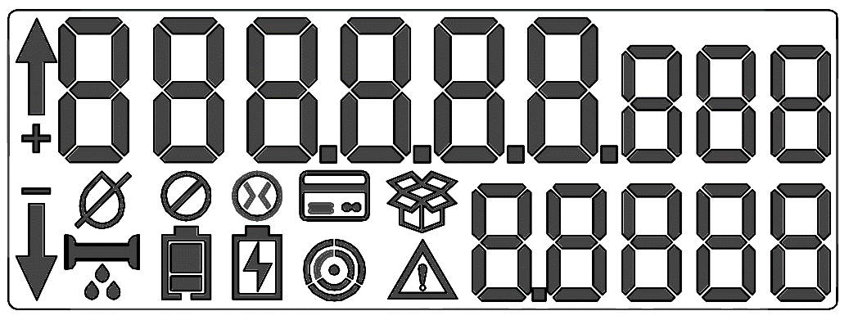

*Figure 5. LCD display segments.*

In fig.5 the display test is presented when all LCD segments are active. Test mode is set using Client’s application via BLE or NFC, by selecting the special test screen from the configured list of screens.

Each measurement value is accompanied by its measurement unit.

The number of decimals is configurable. The volume resolution is 0.000001 m3.

Measured values and states are cyclically displayed on the meter local LCD. The list of parameters to be displayed is configured and includes legally relevant data (consumed water volume).

Almost all the displayed data (both screens and state symbols) are controlled by legally relevant firmware. Display icons are described in Table 8.

*Table 8. Display icons*

|  |  |
| --- | --- |
| **Icon** | **Description** |
|  | It is displayed in case of **TAMPER** event  (attempts to open cover, magnetic field detection etc.). |
|  | Displayed when a **LOWBAT** alarm occurs for external power source  (low battery). |
|  | Displayed when a **LOWBAT** alarm occurs for internal power source  (low battery). |
|  | Communication indicator - displays the **status** and **level** of the WAN channel signal |
|  | Appears when **DRY** alarm  (WM is not filled with water). |
|  | It is displayed at the **LEAK** alarm |
|  | It is displayed at the **BURST** alarm  (possible breakthrough pipe). |
| * | It is displayed when the **threshold** is reached in prepay-mode  (small credit, you need to replenish the account). |
|  | Transportation mode |
| * | It is displayed when the water supply valve is **closed**. (For example, due to non-payment). |
|  | It is displayed when the water supply is limited. |
| ▬  * | Displayed in case **REVERSE** water flow is detected. |
| *  **+** | It is displayed when detecting the flow rate of water above the **sensitivity threshold** of the WM.  The icon blinks in proportion to the flow rate (at least 4 distinct blink frequencies). |

# Communications

The water meter can be accessed locally (via BLE or NFC) or remotely via WAN channels LoRaWAN, NB-IoT,WM-BUS.

Operating hours of WAN channel is configurable. The list of readout data is coordinated with the Client. See actual parameters below.

## 16.1 Bluetooth Low Energy (optional)

Bluetooth Low Energy (BLE) is used to communicate locally with flow control valve and WM software application and to update the WM firmware.

|  |  |
| --- | --- |
| **Standard** | BLE specification v5.3 |
| **Frequency range** | 2.4 GHz |
| **Data exchange rate** | 1 Mbps |
| **Signal level** | Maximum 5 dBm |
| **Battery** | To increase the battery lifespan, BLE operation by a schedule is used. In this case BLE is available at specified time intervals  In case of battery С discharge and main supply off, BLE module is disabled or transmits to ultralow consumption mode |

## 16.2 LoRaWAN

LoRaWAN provides communication at long distances with very low battery usage and ensures data collection, remote monitoring and control.

|  |  |
| --- | --- |
| **Standard** | LoRaWAN specification v1.1 |
| **Frequency range** | EU863-870, US902-928, AU915-928, AS923 |
| **Data exchange** | Bidirectional:   * Data from the WM * Control commands to the WM (for example, open/close the valve) |
| **Data transmission interval** | Configurable  12 hours recommended |
| **Restrictions** | To increase the battery lifespan, LoRaWAN operation by a schedule is used. In this case LoRaWAN is available at specified time intervals |

## 16.3 WM-Bus

Wireless M-Bus being a robust, power efficient, long range wireless communication solution, operates in the license-free ISM bands and is used for remote communication between the meter and HES.

|  |  |
| --- | --- |
| **Standard** | EN13757-4:2019 |
| **Frequency range** | 868 MHz |
| **Operation modes** | Supported modes:  C1, T1 |
| **Data exchange** | Unidirectional synchronous transmission.  Transmission interval: 20 sec, configurable  Interval of consumption Data is 1 hour. |
| **Restrictions** | The WM battery lifespan essentially depends on use case (intensity) of the radio transmission via wireless M-Bus |

## 16.4. NFC

The NFC is short-range wireless technology operating at 13.56 MHz to establish a wireless connection between a reader and a tag.

NFC tag is placed in the WM. When a reader device is brought close to the tag, it can read the information stored in the meter and perform a variety of tasks.

NFC is always active powering from the electromagnetic field generated by reader device.

from the main power source or from the battery, when necessary.

|  |  |
| --- | --- |
| **Standard** | ISO/IEC 15693 |
| **Frequency range** | 13.56 MHz |
| **Data exchange** | Data from WM via a separate reader device compliant with ISO/IEC 15693 or a smartphone |
| **Operation distance** | The read head should be placed not more than 10 mm from WM upper case (in the vicinity of NFC antenna) |
| **Data exchange rate** | 26 Kbps |
| **Restrictions** | In case of external power source connection, NFC interface can be disabled (due to increasing the operation distance) |

## 16.5. NB-IoT

e-SIM card is used

Operates according to LTE Cat NB2 specifications.

NB-IoT unit operates in the following LTE bands (B3, B8, В20).

Flex antenna is placed on the sidewall of the meter.

In case of battery С discharge and main supply off, NB-IoT module is disabled or transmits to ultralow consumption mode.

# Pressure loss

The pressure loss increases with flow rate as shown in Fig.6:

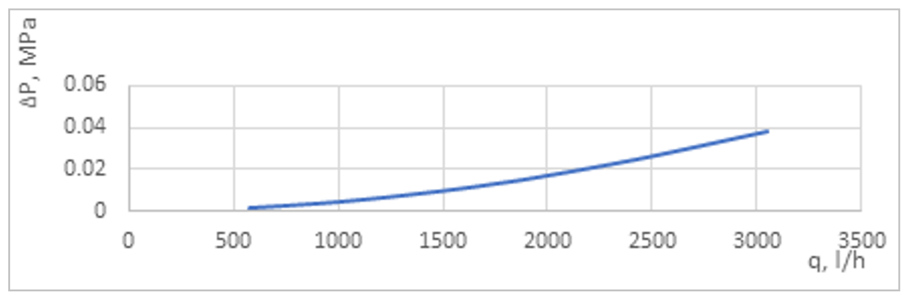

*Fig.6 Pressure loss curve for DN15.*

# Firmware update

Non-relevant part of the meter firmware can be updated locally (via BLE or NFC). The image file is digitally signed by manufacturer to exclude modification.

Before the update is started the meter checks that the image is complete, corresponds to meter type and the digital signature is valid.

# Security features

Encryption is used to provide confidentiality for data to be stored and transferred. WM supports the following security schemes:

**LoRaWAN**:

Based on LoRaWAN® L2 1.0.4 Specification, section 4.3.3 MAC frame payload encryption (FRMPayload)

The encryption scheme features the generic algorithm described in IEEE 802.15.4/2006 Annex B [IEEE802154] using AES encryption with a key length of 128 bits. AES encryption is defined in [NIST-AES].

**WM-Bus:**

Based on Open Metering System Specification Vol.2 Primary Communication, Section 9. Security.

Both supported security cases are described in Table 37 of this Specification: encryption enabled (Security profile A) and no encryption imposed (No security profile).

The security mode is defined in [EN 13757-7:2018], 9.4.4.

**OMS Security profiles**

|  |  |  |  |
| --- | --- | --- | --- |
| **Profile** | **Encryption** | **Authentication** | **Key** |
| No Security profile | No encryption (Security Mode 0)  data are transmitted plain | No MAC (MAC-Mode AT=0) | No key |
| Security profile A | AES128-CBC (Security Mode 5) | No MAC (MAC-Mode AT=0) | 128 bit persistent symmetric key  (with KeyID=0) |

**BLE / NFC / NB-IoT**

Based on the DLMS/COSEM specifications.

Meters support the following security policies:

* Security is not imposed (default).
* All messages are authenticated.
* All messages are encrypted.
* All messages are both encrypted and authenticated.

AES-GCM-128 (Galois/Counter Mode of operation of AES-128 encryption algorithm) Security Suite ID: 0 is implemented for data encryption and authentication, and key transport methods.